**LED Display User Manual**

**Table of contents**

## Safety

1. **Safety Guidelines**
2. **Installation instructions 4 . The type of led display**
3. **Main parts of Led display**
4. **System and external equipment map**
5. **Installation Guides**
   1. **Mechanical requirements and installation**
   2. **Electrical requirements**
   3. **System and power connection guide**
6. **Connection of the LED screen**
   1. **Connection for equipments**
   2. **Port of Cabinet and serial number paint**
   3. **Connection for power cables**
   4. **Connection for data cables**
   5. **Cabinet arrangement drawings sample**
7. **Control system setting**
   1. **Software setup**
   2. **NovaLCT-Mars Main interface**
   3. **Main Menu**
   4. **Tool Bar**
   5. **Screen Config**
   6. **Advanced color configuration**
   7. **Adjust the brightness, Gamma and Current Gain**
   8. **Display Control**
   9. **Check Hardware Info**
   10. **Brightness/Color Calibration**
   11. **Monitor the System**
8. **Servicing**
   1. **Cleaning**
   2. **Calibration**
   3. **Replacement steps**
9. **Normal issues and solution during operation period**
   1. **Display screen problem**
   2. **Cabinet problem**
   3. **Module problems**



1. **Safety**

**Grounding**

The combination of multiple cabinets in an installation results in increased levels of leakage current. In order to avoid risk of electric shock due to high leakage current, proper grounding of the installation is required.

Defeating the purpose of the grounding type plug will expose you to the risk of electric shock.

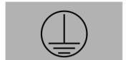Grounding symbols

## Electric safety

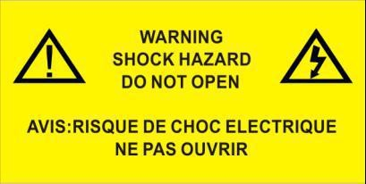Do not open equipments with below symbols. To reduce the risk of electric shock, do not remove cover (or back). No user-serviceable parts inside. Qualified service personnel is required for serving.

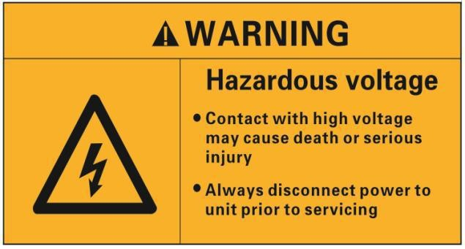High voltage symbols

High voltage symbols

The lighting flash with an arrow head within a triangle is intended to tell the user that parts inside this product may cause a risk of electrical shock to persons.



# Safety Guidelines

## Personal protection

Ensure you understand and follow all the safety guidelines, installation instruction, warnings and symbols.

Mind yourself while working with heavy loads and high voltage.Contact with high voltage may cause death or serious injury. Always disconnect power to the display cabinet or cabinets prior to servicing.All personnel at the LED Video Board installation site are required to have personal protection equipment (PPE) such as hard hats, safety glasses, gloves, harnesses, and other appropriate safety equipment.

## Equipment protection

Ground the LED display screen before connecting the power source.

Contacting displays that are not earth-grounded may cause death or serious injury.

Do not use the LED display screen ground lugs for installation equipment such as welding equipment.Structural & mounting components should be kept dry, clean, lubricated (only if recommended), coated properly, and maintained in a manner consistent with part design. LED products must be installed and operated in a manner to reply on its design and inspection a routine basis for security, wear, deformation, corrosion and any other circumstances that may affect the load handling capability of the part. We recommend inspections at regular intervals for all installations and increasing in frequency for more critical installations. A part is damaged which may cause a decrease in load capability. The part must be removed for service or replaced immediately. Always follow LED display screen installation instruction.

Contact the support technical person if user has any question regarding the safety of an application. The manufacturer assumes no liability for incorrect, inadequate, irresponsible or unsafe assembly of systems.

# Installation instructions

## Instructions

Read these instructions.Keep these instructions.Heed all warnings.Follow all instructions. Do not block ventilation openings. Please install in accordance with the manufactures instructions.Avoid installation near heat sources such as radiators, heat registers, stoves, or other apparatus (including amplifiers) that produce heat. We suggest the user install some equipment to reduce the heat if any.

Do not break the safety purpose of polarized or grounding type plugs/sockets. If the provided sockets/plugs are damaged then replacement of the detective parts must be undertaken immediately.

Protect the power/data cords from being taken off or pinched particularly at plugs, convenience receptacles, and the point where they exit from the apparatus. Replace damaged power/data cords immediately.

Only use attachments/accessories specified or provided by the manufacturer.

Use with caution during lifting/moving or transporting to avoid damage by possible crash. After receiving the LED display screen, please uncover all the boxes and cases, count and check all things compare with the packing list. If there is any problem such as missing or damaged part, contact the manufacture immediately.

# The type of LED displays

## Fixed type

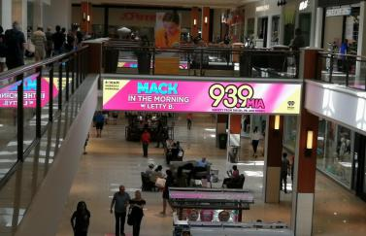

Outdoor use Indoor use Mobile LED Truck

## LED facade

 

Outdoor use Indoor use

## Rental type

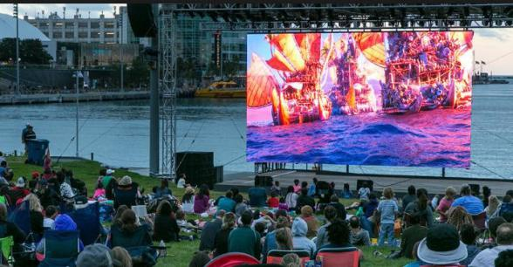 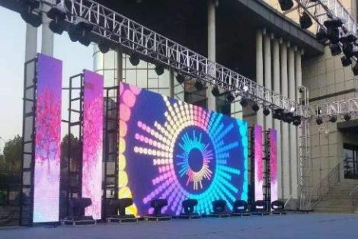

Outdoor use Indoor use

1. **Main parts of Led display**

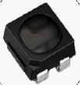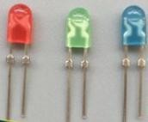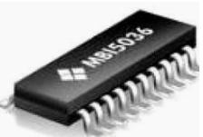

# SMD LED DIP LED Drive IC

# 2) Signal cable

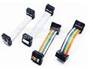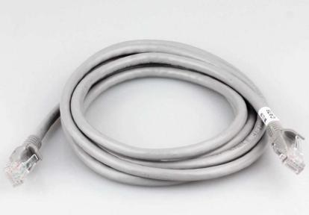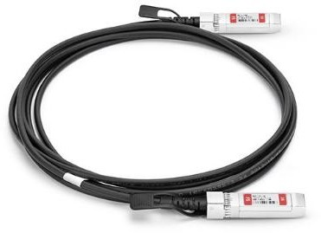

**Pin cable CAT 5 cable Fibre-optical 3)Power cable**

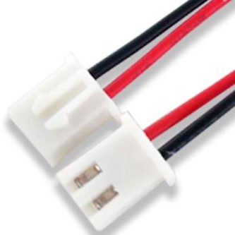 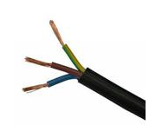 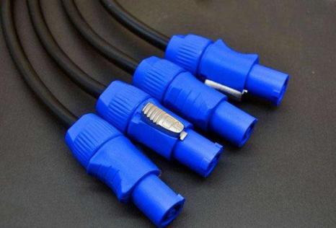

#### DC power cable to module AC220V/110V power cable Power cable for rental LED display

1. **LED sockets**

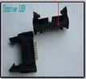 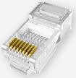

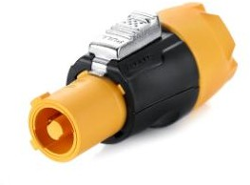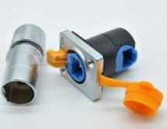

**Power socket Signal socket Anti-loosing socket CAT5 socket**

1. **LED fan & power supply**

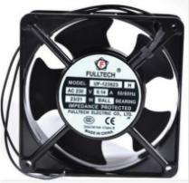 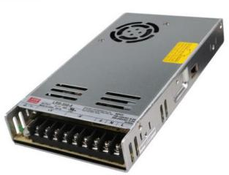

### Fan Power supply

1. **Main types of power sockets**

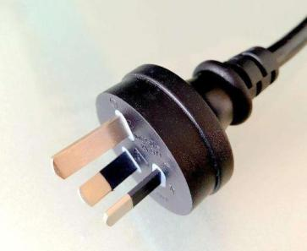

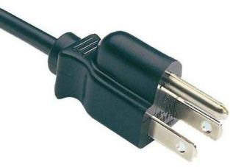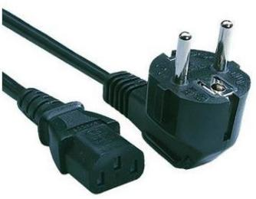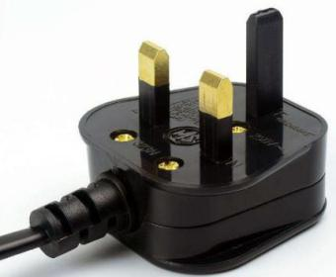

### American standard European standard UK standard Australia standard

1. **LED module,mask & Screws**

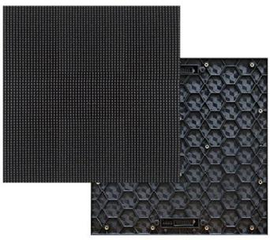

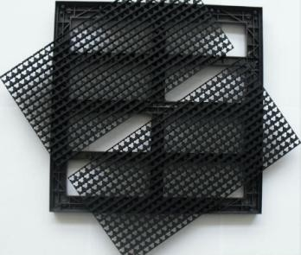

**LED module Mask screws**

1. 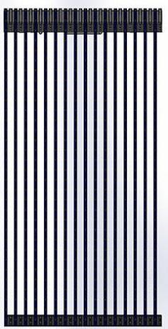**LED panel**

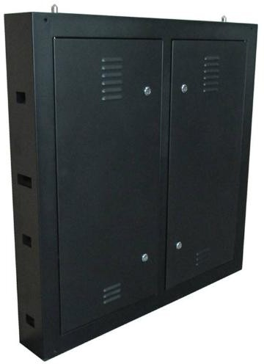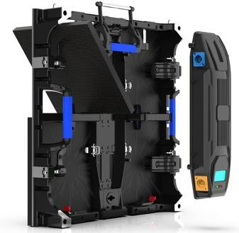

### Fixed type Rental type LED facade

1. **LED hanging bar,stacking support & flight case**

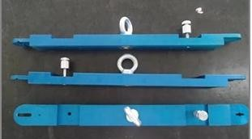 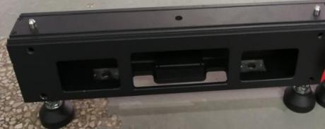 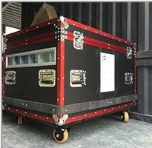

### Hanging beam Stacking support Flight case

1. **Control system**

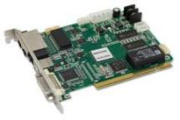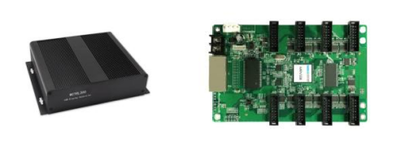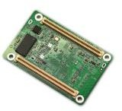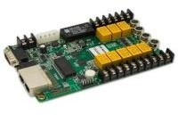

**Sending card sending box receiving card mini receiving card MFN300**

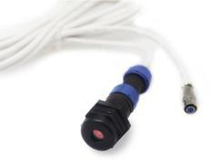 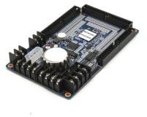 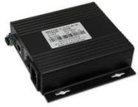 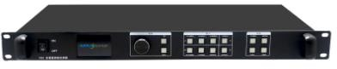

### NS060-5A MON300 fiber converter video processor



1. 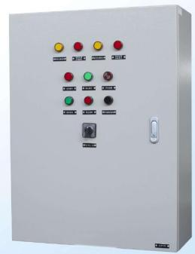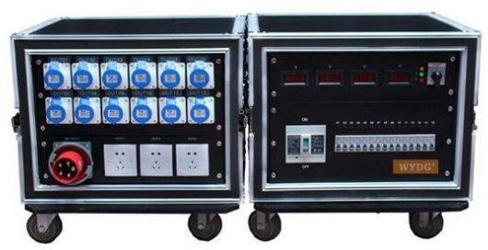**AC power distribution**

**For fixed LED display For rental LED display**

1. 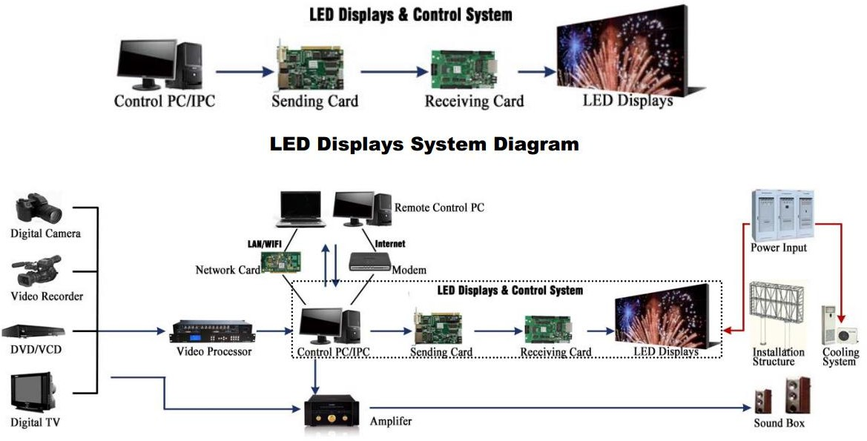**System and external equipment map**

For fixed LED display

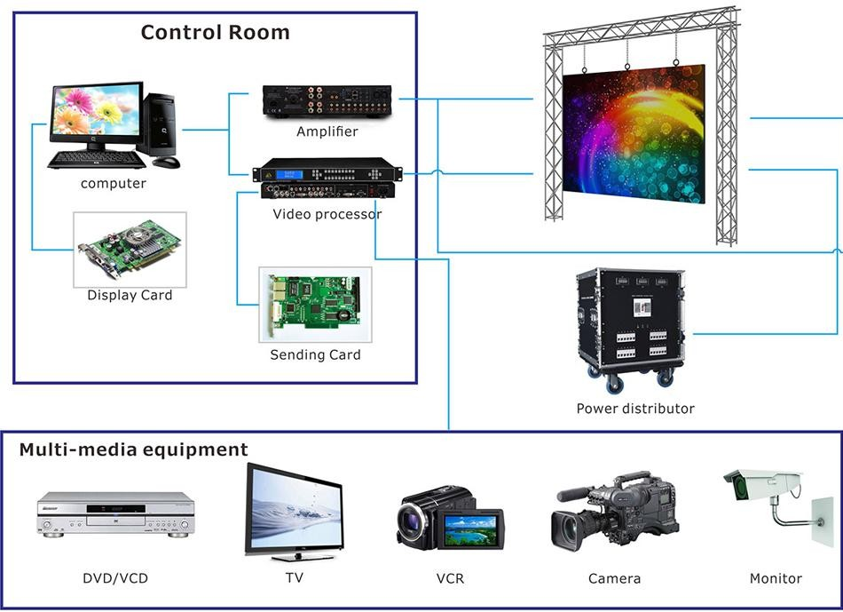

For rental LED display

# Installation Guides

## Mechanical requirements and installation

### Support structure

The support structure has to be provided and installed by the customer because they vary from project to project. The following issues must be considered:

**Weight tolerances:** Ensure that the support structure and the floor on which or the wall against which the support structure has to be installed, is qualified to handle the complete weight of the LED display screen.(which can be provided by manufacturer.

**Environmental conditions**: Humidity, wind, temperatures, rain, snow etc.

**Location**: Outdoor/.Indoor, altitude, etc. Usually, for outdoor display screen, the customer should build top cover and side cover for IP protection (Including waterproof and dust proof)

#### Ground stability

**Front clearances:** For making sure there is sufficient free area in front of the LED display screen and respect the maximum viewing angles and distance.

#### Local regulations regarding such installation

**Tools for installation**

**Please prepare below tools before installation**

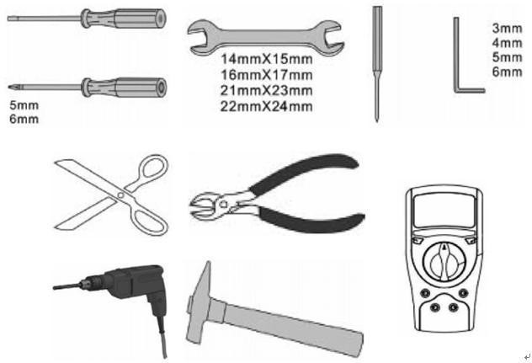Slot type screwdriver, Philips type screwdriver, spanner, Hexagonal bar, Hexagonal head screwdriver, scissors, pincers, wire cutters, hammer, electric drill, electric welding, Multi- meter, etc.

32

**Installation of cabinets Fixing of connect plate**

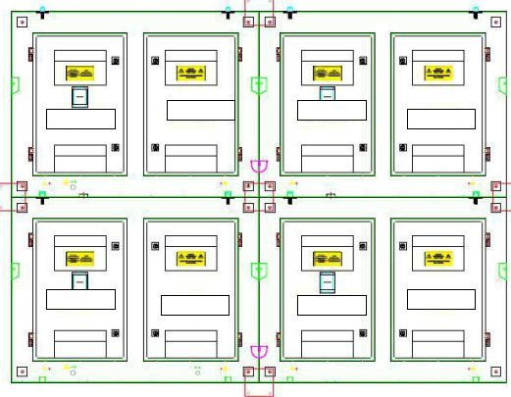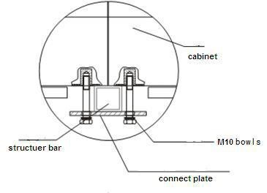

### Details of installation

1. 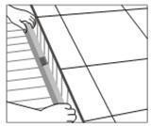First measure the under surface of the structure as a horizontal plane and the side of the structure as a vertical plane by spirit level as shown as below
2. First cabinet is placed in the middle of the bottom row with the stud rods in the middle of the corresponding slot as shown as below, do not fix the nuts tightly.
3. Place the cabinets beside one another from the middle of the row to the sides as shown as below, do not fix the nuts tightly
4. Finish the first row by same way.
5. Measure the first row by spirit level, make sure it is installed horizontally, then fix the nuts tightly between the cabinets and the connect plates.
6. Pace the middle cabinet in the second row, adjust it and fix it but not tight. Make sure it is installed horizontally and vertically, then fix it tightly.
7. Finish the second row by the same way.
8. Finish the rest installation of all the cabinets by the same way.

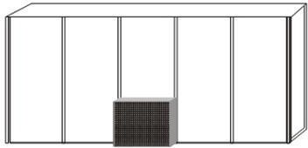  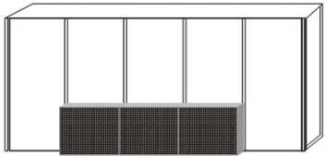

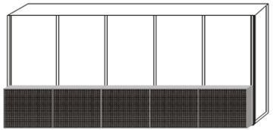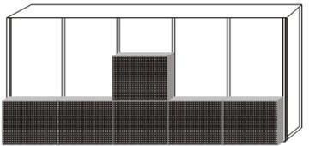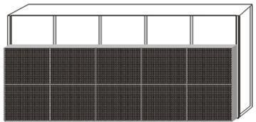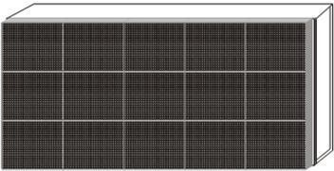

Simple instruction for rental led display installation

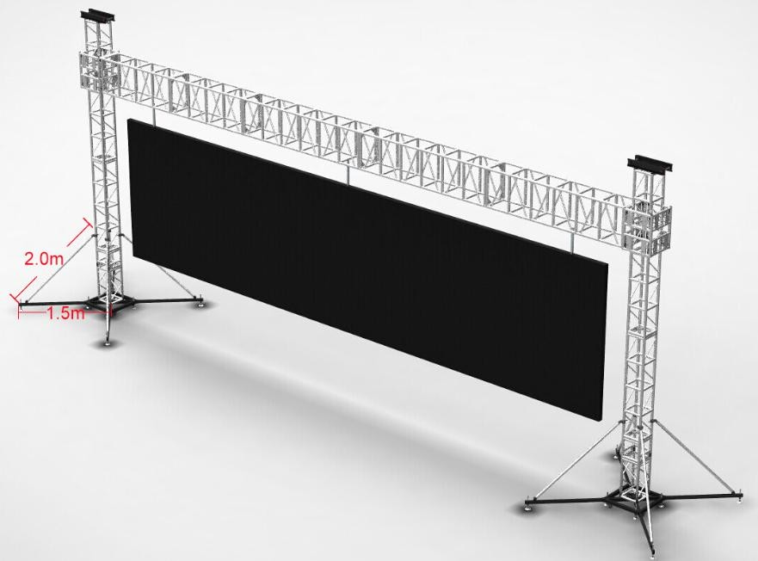



# Electrical requirements

## Power system

Power voltage must be in the range of the specification value.

It is recommended to use a power distribution system (a power distribution system with a separate neutral and grounding conductor in order to avoid large ground current loops due to voltage differences in the neutral conductor.

The total electrical installation should be protected by an appropriately rated disconnect switch, circuit breakers.

The electrical installation must only be performed by a qualified electrician. Electrical connections must comply with all applicable national and local codes.

## Cabling & Connection

All internal cabling must be properly connected and seated.

All power wiring must be from circuit breaker protected lines. Do not connect to an unprotect circuit.

Do not route power and communication wires in the same conduit. Separate conduits must be run for communication wires and power wires. However, fiber optic wire may be run in the same conduit with power wires.

## Grounding

The LED display screen must be properly grounded according the applicable national and local codes.

Properly grounding every display cabinet is necessary as it is essential to prevent shock, shock hazards, and fire hazards.

## Lighting Strike Protection

A LED display screen cabinet bonder to an earth ground aims to dissipate the high voltage and current from a lighting strike. The resistance of the grounding electrode must be as low as possible. However, damage can still occur to a LED display screen cabinet`s electronic equipment from lighting voltage transients.

Though some surge protection is incorporated into a LED display screen in order to protect the display from high voltage lighting transients, surge protectors need to be installed.



## Lighting Strike Protection of Electric Closet

Every electric closet of LED display screen must be installed with lightning protection device equipment. The requirement specification should be same as shown below. Nominal discharge current In (8/20µs) :20 kA

The maximum discharge current Imax (8/20µs):40 kA Voltage protection level:

Up in ln AC385-505V:≤1.7kV TA ˂25ns

## Lighting Strike Protection of Cabinet

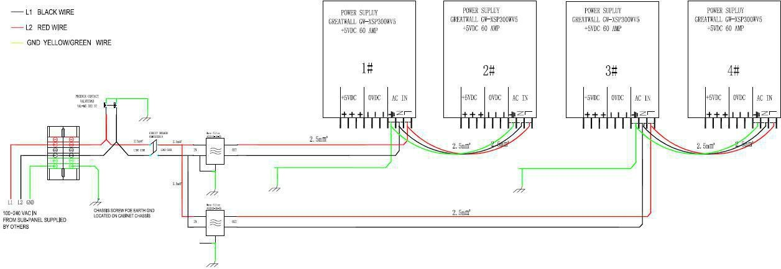

Every cabinet which connect power input cable from electric closet have installed the surge protector. So when you install the LED display screen cabinet, must finish it according to the LED display cabinets arrangement drawing.

# System and power connection guide

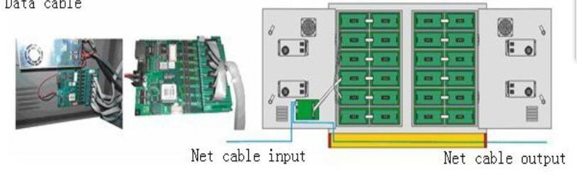



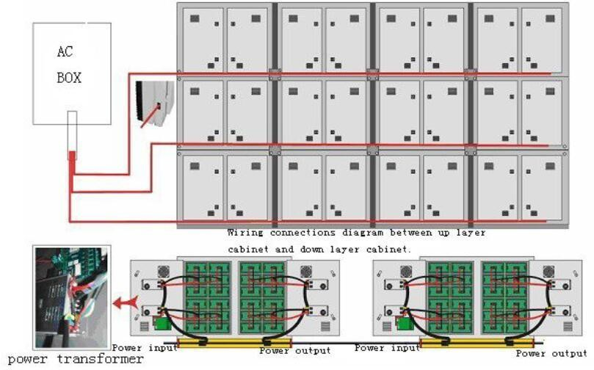



1. **Control system setting**
   1. **Software setup**

## It is sample to install the <NovaLCT-Mars> as below:

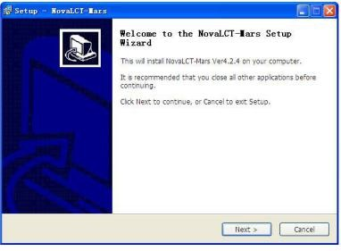Double-click NovaLCT-Marssetup file, select <Next> to start, follow the guides to finish the setup.

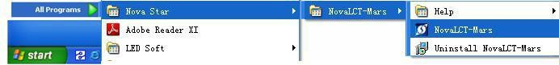When the setup of the < NovaLCT-Mars> is completed, the <LED software> will show up in the <Start/<Program>. Click to start operation after entering < NovaLCT-Mars> in the program.

There are shortcuts of < NovaLCT-Mars> in the desktop as icon shown, double-click it to start up the program



# Nova LCT-Mars Main interface

## This section describes how to use NovaLCT-Mars to set screen parameters as follows:

**Enter NovaLCT-Mars main interface**

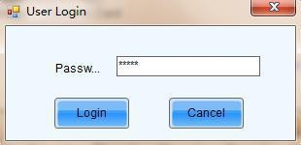**Step 1:**Start “NovaLCT-Mars", click ""User" → "Advanced Login", enter `User login` window as shown in Fig.9-3

Fig 9-3

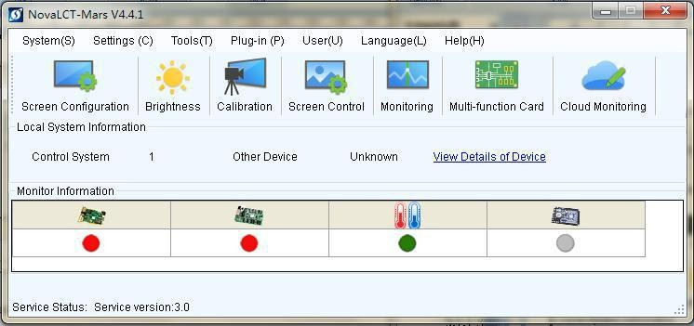**Step 2:**Input the password `666`, enter the NovaLCT-Mars main interface for advanced users

# Main Menu

Pls refer the Manul attached to Help menu.

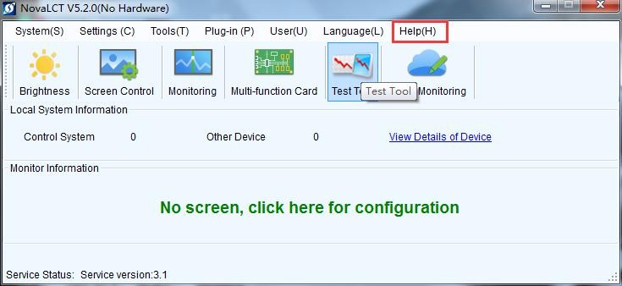

1. **Service**
   1. **Cleaning**

**For outdoor LED display screen**

Due to outdoor use the LED display screen are exposed to all kinds of weather conditions. Sand, dust, smog and other dirty things on the LED display and because of that the performance of the LED display may be effected, So regular cleaning on LED display is recommended.

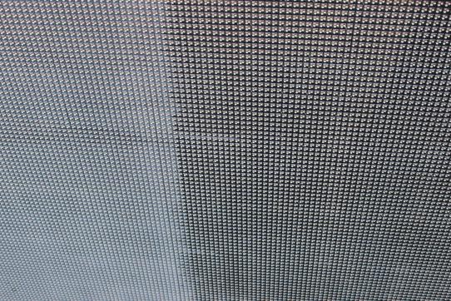

LLED`s and shades covered with dirt Clean LED`s and shades

Clean all the cabinets of the LED display screen to avoid brightness differences between cleaned and unclean cabinets.

**Necessary tools**

Vaporizer with cleaning detergent

Soft hand brush with long hair (recommended 4 cm pork hair) Garden hose with a spray nozzle

Air compressor

## Cleaning steps

* + 1. Seal up the data and power sockets using a power and data linking cable. Make sure that all plug holder clamps are locked firmly.
    2. Put the detergent on the shades and LED`s part by part of the LED display screen. Do not use industrial grease removers. Use only materials or chemicals that are inert, non-corrosive and non-marking.
    3. Brush down all the dirt of the LED`s and the shades using a soft hand brush. Do not use a hard bristled brush.
    4. Wash away the remaining soap with plenty of fresh water.
    5. Repeat from step two until the part is clean.
    6. Dry the surface with air compressor.
    7. Clean the LED display screen from top to bottom.
  1. **Calibration**

## Factory calibration

In order to achieve color uniformity among all cabinets of the same display the cabinets can be color calibrated to improve display effect of the LED display screen. The manufacturer can do calibration before goods are delivered out of factory.

## Site calibration

When the LED display screen is running for a long time, for example for one year, some part of the display screen may play a different image from other parts. Chromatic aberration will appear on the LED display screen. Then a site color calibration is needed to achieve color uniformity among all cabinets of the LED display screen, please contact Sales & Service for further details.



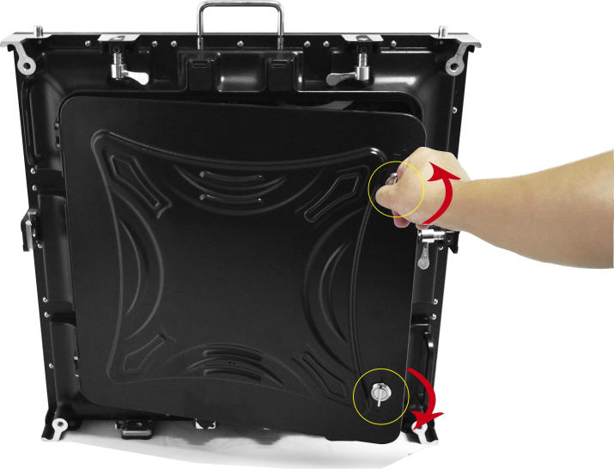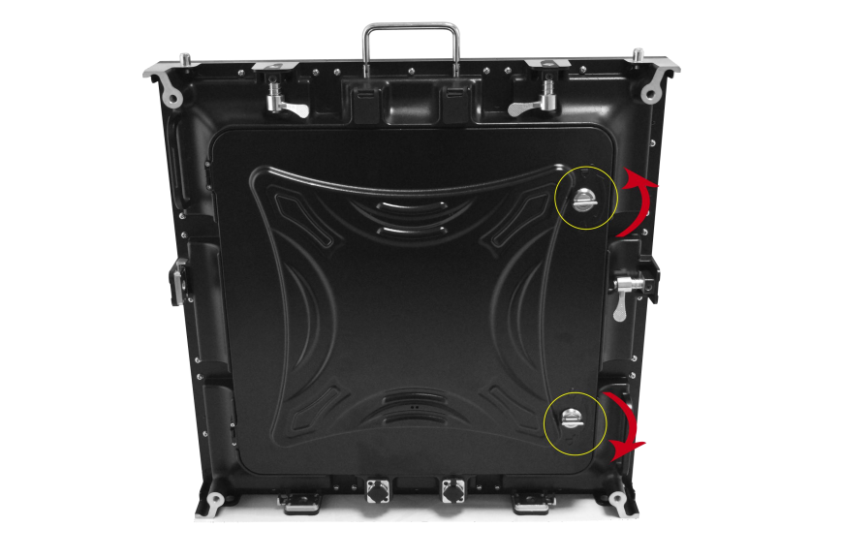

# Replacement steps

## Open cabinet

Before replace the bad parts in cabinet, you need to open the back door of cabinet by key as shown below.

Before you replace the electrical parts, please ware the ESD protection gloves first.

## Power supply

Power off the cabinet where the power supply is in

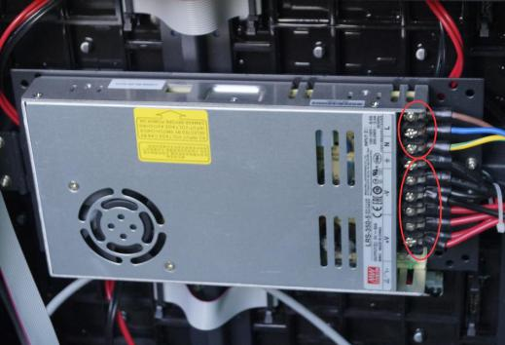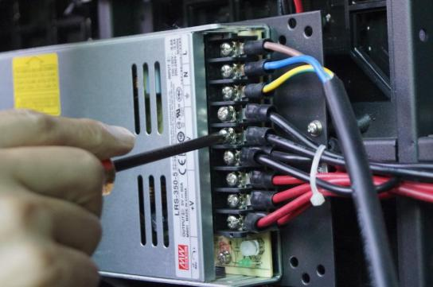Take off all the cables connected to the power Take off all the DC cables by screwdriver Supply as shown below as shown below

Take off all the AC cables by screwdriver Remove the patching board by screwdriver as shown below as shown below

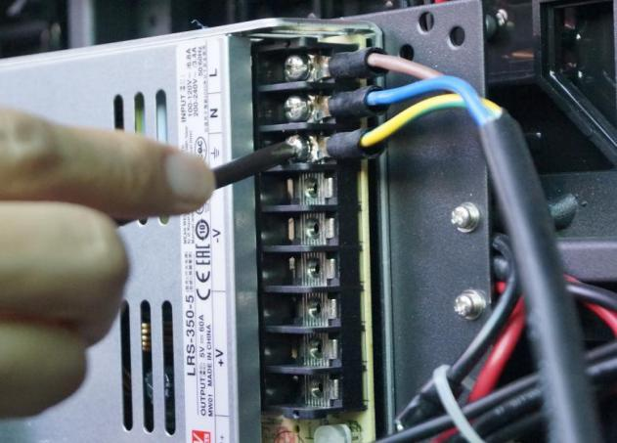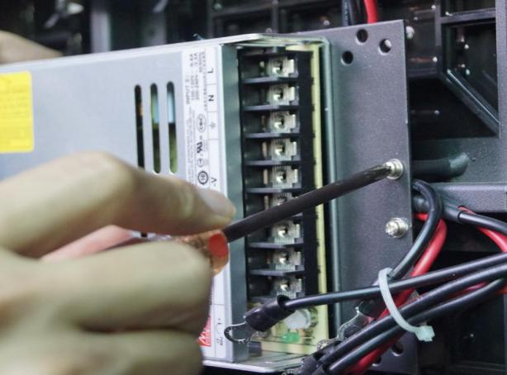

Remove the bad power supply from the patching board by screwdriver and install he spare power supply onto the patching board,connect the AC and DC power cables accordingly, then power the cabinet on.



## Receiving card

Power off the cabinet where the receiving card is in,

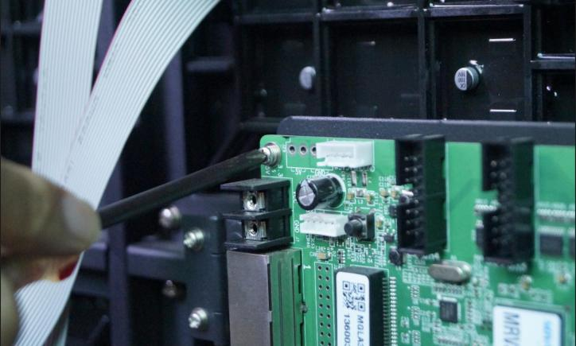Take off the DC cables and flat cables from the Remove the bad receiving card from receiving card by screw driver as shown below the plate board

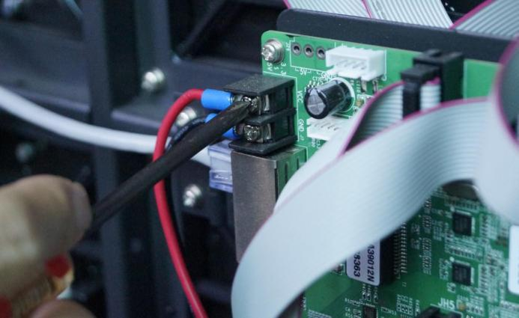

Install the new receiving card into box by screwdriver.Install the DC power cable and flat cable onto receiving card,then power the cabinet on.

## Module

Power off the cabinet where the module is in

Take off all the cables connected to module,remove all the screws which fix the module on the cabinet structure as shown below.

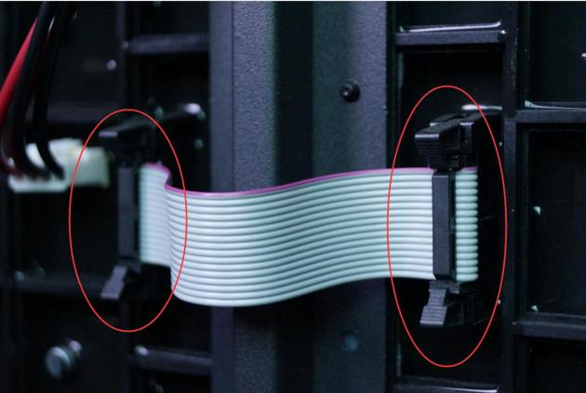 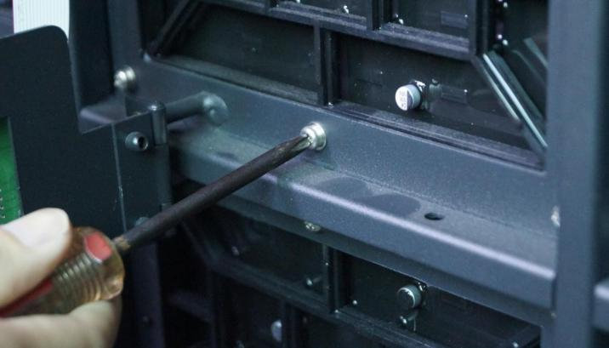

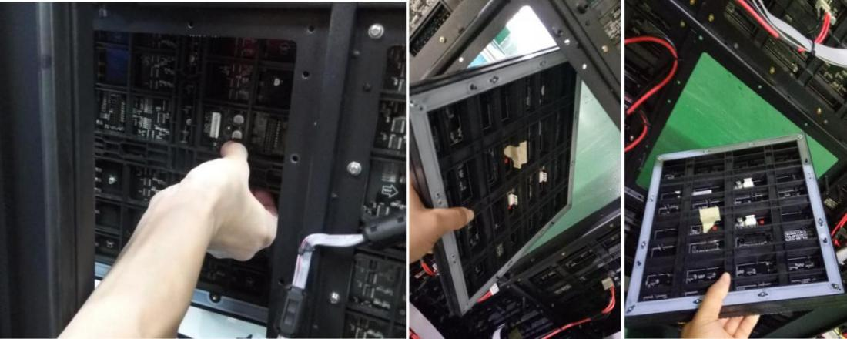Remove the bad module and take it out from back side as shown below.

Handle the back cover by hand

Put the new module on the cabinet structure and install all the screws by screwdriver.Connect all the cables to the new one correctly.Turn on the cabinet.

After replacing modules, the customer should update the calibration data for that module in the receiving card. Operation details are shown in chapter 9.10. All the spare module have a serial number as JH1, JH2, JH3 etc.

# Fan

Install the new one.

Power off the cabinet where the fan is in,remove the bad fan by screwdriver and take the fan out by hand as shown below.

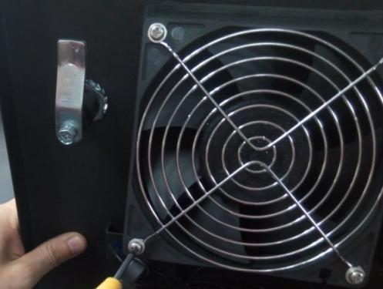 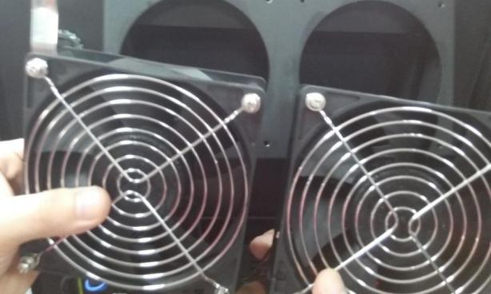

Take off the AC connection cable by hand as shown below.

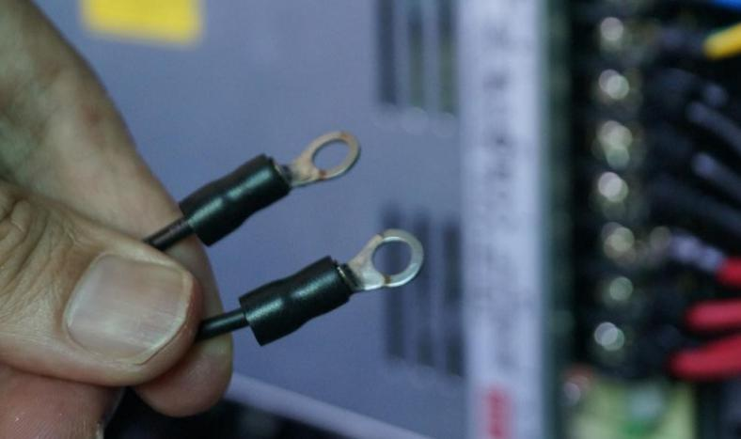

Install the new fan into the cabinets by screw.Connect the AC connection cable to the fan and power supply.

**Signal input cable and Signal cascade cable**

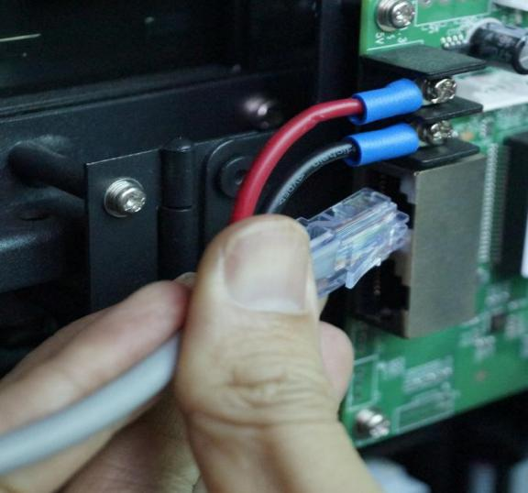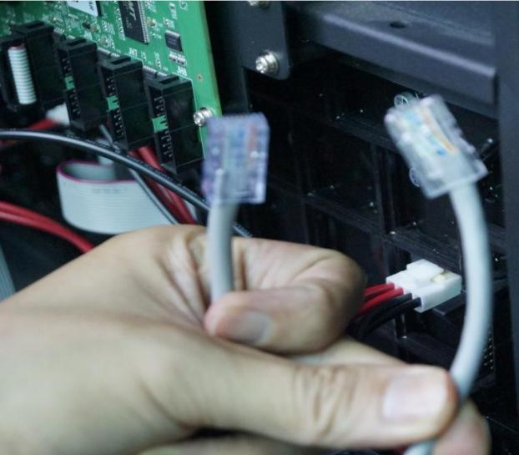Take off the bad one & Install the new one.

**Pin cable**

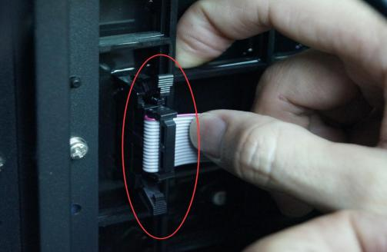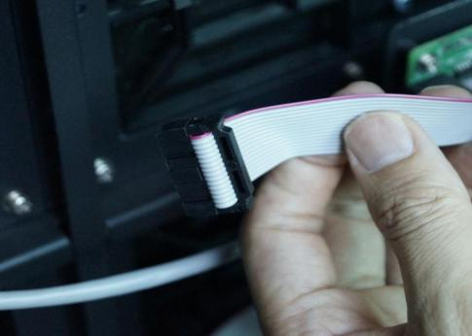Remove the bad one

# DC power cable

Power off the cabinet where the DC cable is,

Take off the bad one & Install the new one.Turn on the cabinet.

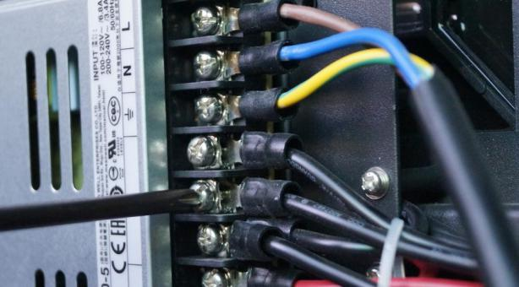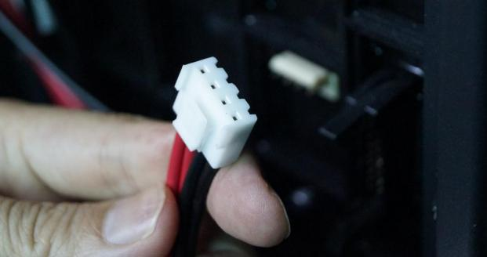

1. **Normal issues and solution during operation period**
   1. **Display screen problem**

|  |  |  |  |
| --- | --- | --- | --- |
| **The whole display screen cannot light up** |  | Check belows is available or not | 1. the display screen is power on; 2. the connection is broken between Sending box box and the display screen; 3. the sending box is normal; 4. the first cabinet is working normally in the display; 5. the brightness setting is 0%; 6. the software setting is correct. |
| **The whole display screen is blinking** |  | Check belows is available or not | 1. the connection is broken between PC and Sending box; 2. the connection is broken between Sending and the display screen; 3. the sending box is normal; 4. the first cabinet is working normally; 5 the software setting is correct. |
| **Part of the display screen cannot light up** |  | Check belows is available or not | 1. the part is power on; 2. the power supply is broken; 3. the connection is broken between cabinets; 4 the receiving card is normal; 4. the software setting is correct; 5. the program in receiving card is correct. |
| **Part of the display screen is blinking** |  | Check belows is available or not | 1. the connection is broken between cabinet and cabinet; 2. the receiving card is normal; 3 the software setting is correct;   4 the program in receiving card is correct. |

|  |  |  |  |
| --- | --- | --- | --- |
| **The display screen is out of control** |  | Check belows is available or not | 1 the USB cable is connected well; 2 the USB cable is broken;  3 the software is running well. |
| **The display screen display wrong image** |  | Check belows is available or not | 1 the connection table setting is correct; 2 the software setting is correct;  3 the program in receiving card is correct. |

* 1. **Cabinet problem**

|  |  |  |  |
| --- | --- | --- | --- |
| **The cabinet cannot light up** |  | Check belows is available or not | 1. the cabinet is power on ; 2. the connection is broken between cabinets; 3 the receiving card is normal; 3. the power supply is broken in cabinet; 4. the program for receiving card is correct. |
| **The cabinet is blinking** |  | Check belows is available or not | 1. the receiving card is broken; 2. the connection is broken between cabinets . |
| **Part of the cabinet cannot light up** |  | Check belows is available or not | 1 the power supply is broken; 2 the flat cable is broken;  3 the DC power cable is broken; 4 the HUB board is broken;  5 the module is broken. |
| **Part of the cabinet is blinking** |  | Check belows is available or not | 1. the flat cable is broken; 2. the HUB board is broken; 3 the module is broken. |

* 1. **Module problems**

|  |  |  |  |
| --- | --- | --- | --- |
| **The module cannot light up** |  | Check belows is available or not | 1 the DC cable is broken; 2 the flat cable is broken; 3 the module is broken;  4 the last module is broken. |
| **The module cannot light up** |  | Check belows is available or not | 1 the flat cable is broken; 2 the module is broken;  3 the last module is broken. |
| **The module is blinking** |  |  |  |
| Block of module is broken or column of module is broken | Check belows is available or not | 1. the driver IC is broken; 2. the soldering of the driver IC is broken.. |
| **Row of module is broken** |  | Check belows is available or not | 1. the 4973 IC is broken; 2. Check if the soldering of the 4973IC is broken. |
| **Row of module is broken** |  | Check belows is available or not | 1 Check belows is available or not; 2 the soldering of led is broken. |

**How to check the status of the transmitting card?**

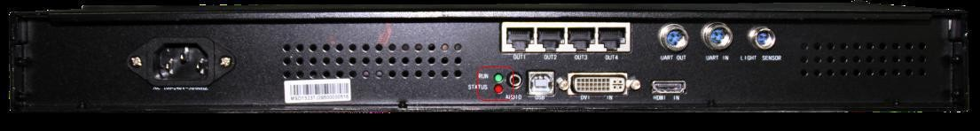There are two lights on the transmitting card as shown as below.

If everything is right, the Red one will be off and the Green one will be blinking. Otherwise the user needs to check graphics card setting, DVI cable and transmitting card.

# How to check the status of the receiving card?

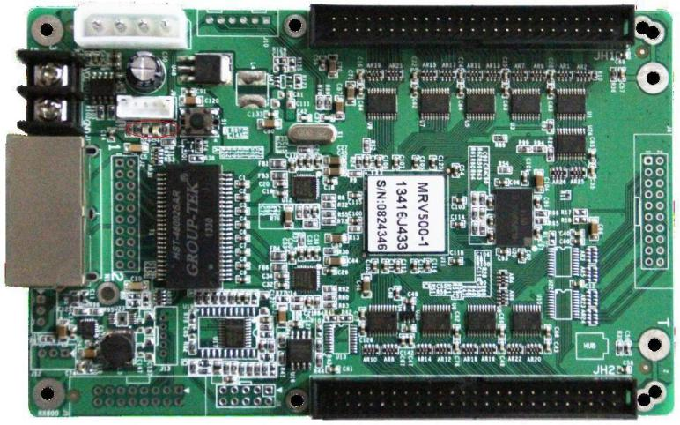There are three lights on the receiving card as shown below



If everything is right, the Red one is blinking, and the Green one is on (no blinking). Otherwise the user needs to check receiving card, the programmer, and the Cat-5 cable connect into this scan board.

# How to check the input and output problem of board?

Usually there are one input and one output on board. If a board is broken, we can get data from another board to check the input of this board is good or not. Also, we can get data from last board to another board to check the output of last board is good or not.

# Checking Method

**Jump signal from the last module to another module, or jump signal from the current row to the next row**

